City of Carlos

109 1st Street West

P.O. Box 276

Carlos, MN 56319

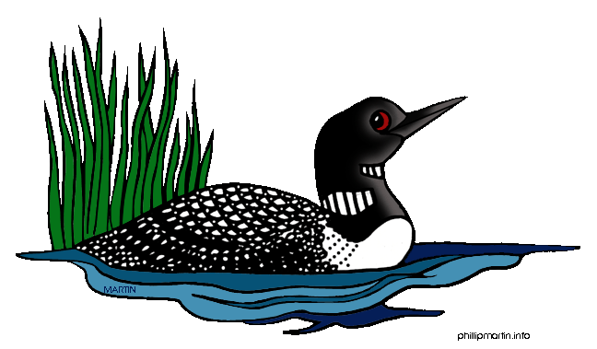

(320) 852-3000

office@cityofcarlos.com

Website: cityofcarlos.com

**Dog License Application/Renewal Form**

Please return the form to

City Hall located at 109 1st Str. W, Carlos, MN 56309

**\*Please use a separate form for each dog. \***

Date ________________________________________ 1 Year License Fee: $10.00

Name of Owner____________________________________________________________________________________________

Address of Owner__________________________________________________________________________________________

Phone Number___________________________________Email____________________________________________________

Name of Dog ________________________________________Breed of Dog _________________________________________

Gender of Dog: (circle one) Male Female Spayed or Neutered: (circle one) Yes No

Description _______________________________________________________________________________________________

__________________________________________________________________________________________________________

***I understand that the annual individual dog license fee (currently $10) will be collected in May of each year via the city utility bill (water/wastewater bill).

***It is your responsibility to notify the City Clerk at 320-852-3000 or email [office@cityofcarlos.com](mailto:office@cityofcarlos.com) if you no longer have a pet.

**Please provide a current (required) rabies vaccination certificate.**

**Vaccination shall be performed only by a doctor qualified to practice veterinary medicine**

**in the state in which the dog is vaccinated.**

Signature of Applicant_________________________________________________________________________________

………………………………………………………………………………………………………………………………………………………………

**For City Use:**

Fee Received___________________ Tag#:_______________ Dog License Expires ___________________________________

Date Rabies Shot Expires __________________________________Veterinary Clinic_________________________________